Steps to add the Add-in to Power Point:

* Download and save below “AutoEvents.ppa” to your local system.



* Open New PowerPoint File.
* 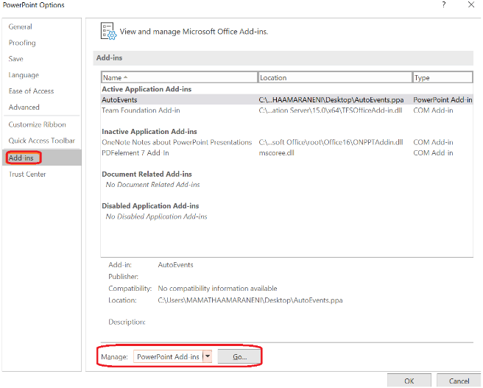Go to File-->Option-->Add-ins

|  |
| --- |
| * Click on “Go” then click on “Add New” and add the downloaded “AutoEvents.ppa” from Add-ins dialog box. |

